Programming 2
Tutorial 3
Exercise 1 (required)
Implement a class called Circle which is defined as shown in the class diagram below. It contains two private instance variables: radius (of type double) and color (of type String); and three public instance methods: getRadius(), getColor(), and getArea().
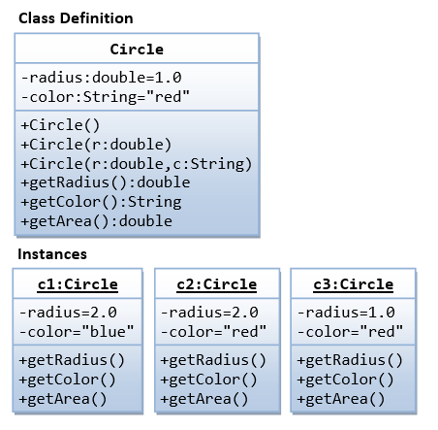
Create three instances of Circle, called c1, c2, and c3. These objects shall be constructed with their respective data members, as shown in the instance diagram below.
Exercise 2 (required)
A class called Rectangle, which models a rectangle with a length and a width (in float), is designed as shown in the following class diagram. Write the Rectangle class.
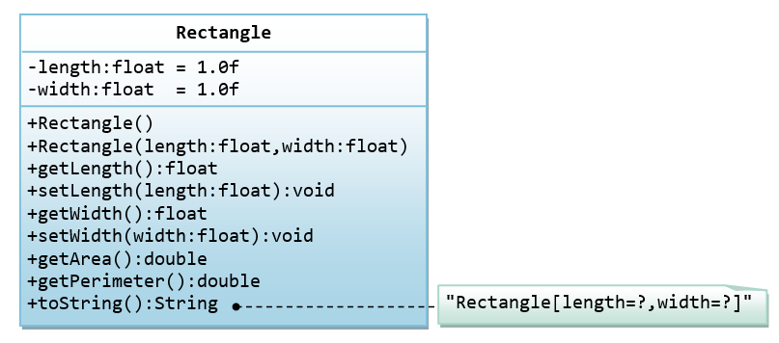
Following main method can be used to test Rectangle class:
public static void main(String[] args) {
Rectangle r1 = new Rectangle(1.2f, 3.4f);
System.out.println(r1); // test toString()
Rectangle r2 = new Rectangle(); // test default constructor
System.out.println(r2);
// Test setters and getters
r1.setLength(5.6f);
r1.setWidth(7.8f);
System.out.println("Length is: " + r1.getLength());
System.out.println("Width is: " + r1.getWidth());
// Test getArea() and getPerimeter()
System.out.printf("Area is: %.2f%n", r1.getArea());
System.out.printf("Perimeter is: %.2f%n", r1.getPerimeter());
}
The expected output is:
Rectangle[length=1.2,width=3.4]
Rectangle[length=1.0,width=1.0]
Length is: 5.6
Width is: 7.8
Area is: 43.68
Perimeter is: 26.80
Exercise 3 (required)
A class called Employee, which models an employee with an id, name and salary, is designed as shown in the following class diagram. The method raiseSalary(percent) increases the salary by the given percentage. Write the Employee class.
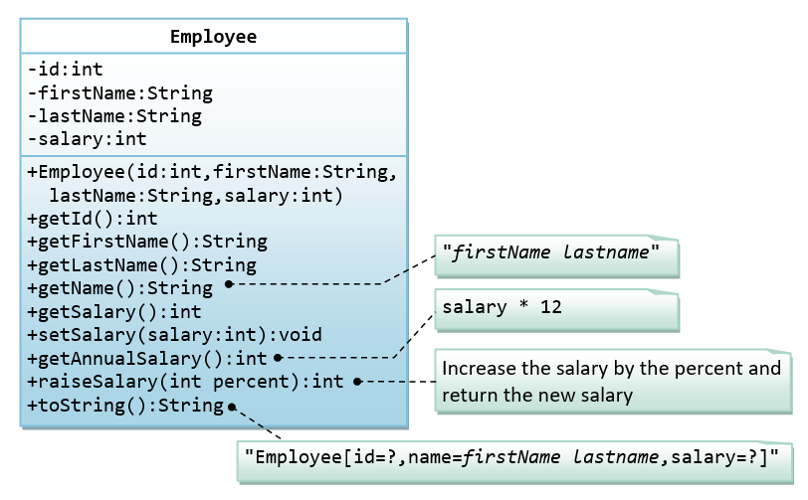
Write code to test the Employee class just like we have tested the Rectangle class above.
Exercise 4 (optional): Point2D.java
A class called Point2D represents a point in a two-dimensional plane. The UML diagram for the class is shown in the following figure:
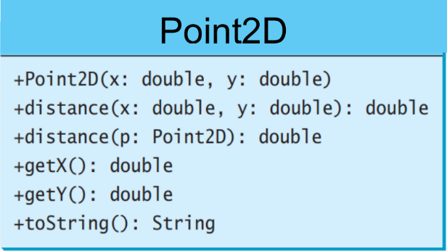
Create a Point2D object for a point with the specified x- and y-coordinates, use the distance() method to compute the distance from this point to another point, and use the toString() method to return a string representation of the point.
Sample run output:
